|  |  |  |  |  |  |  |  |  |  |  |
| --- | --- | --- | --- | --- | --- | --- | --- | --- | --- | --- |
| Project/Dissertation Module Number:   |  |  |  |  |  |  | | --- | --- | --- | --- | --- | --- | | U | O | 4 | 6 | 9 | 2 | | | | Credit Value (eg single, double)   |  | | --- | | DOUBLE | |
| Title:   |  | | --- | | MECHANICAL RADIAL ERROR CORRECTION | | | | |
| Student Number   |  |  |  |  |  |  |  |  | | --- | --- | --- | --- | --- | --- | --- | --- | | 0 | 7 | 0 | 8 | 9 | 7 | 0 | 4 | | | | |
| Surname: | | Forenames: | |
| |  |  | | --- | --- | | HUDSON | MARC | | | | |
| Subject(s) for which acceptable   |  | | --- | | PROJECT | | | | |
| Date of Submission: (dd/mm/yyyy) | |  | | --- | | 04-04-14 | | | |

This Dissertation is submitted in part fulfilment of the regulations for BA/BSc/BMedSci/BEng/BOst/LLB Honours Degree and the MEng

**Oxford Brookes University**

Statement of originality

Except for those parts in which it is explicitly stated to the contrary, this project is my own work. It has not been submitted for any degree at this or any other academic or professional institution.

Signature of Student:

…………………………………………………………………………..

Date: ………………..

**Regulations Governing the Deposit and Use of Oxford Brookes University Modular Programme Projects and Dissertations**

1. The ‘top’ copies of projects/dissertations submitted in fulfilment of Modular Programme requirements shall normally be kept by Faculties.
2. The author shall sign a declaration agreeing that the project/dissertation be available for reading and photocopying at the discretion of the Dean of Faculty in accordance with 3 and 4 below.
3. The Dean of Faculty shall safeguard the interests of the author by requiring persons who consult the project/dissertation to sign a declaration acknowledging the author’s copyright.
4. Permission for any one other than the author to reproduce or photocopy any part of the dissertation must be obtained from the Dean of Faculty who will give his/her permission for such reproduction only to an extent which he/she considers to be fair and reasonable.

I agree that this dissertation may be available for reading and photocopying at the discretion of my Dean of Faculty in accordance with regulations 3 and 4 above. *

Signature of Student: …………………………………………………………………………..

Date: ………………..

*The underlined words may be deleted by the author if s/he so wishes

Mechanical Radial Error Correction

MARC HUDSON

07089704

BSC COMPUTER AIDED MECHANICAL ENGINEERING

Oxford Brookes University Department of Mechanical Engineering and Mathematical Sciences

Submission Date: 04-04-2014

Academic Year 2013-2014

**abstract**

There are countless applications in electro-mechanical engineering all over the world that utilize one kind of control system or another. From the control of the temperature in people’s homes, to the minute adjustments being made to alter the path of an electron beam from a particle accelerator. These control systems are what allow us to depend on the operation of machines producing consistent results. In the music world, from professionals to beginners alike, there are but a few tools to aid musicians in getting consistent accuracy with the tuning of their instrument. In this paper, a device has been designed to help musicians in tuning their guitars by taking the factor of human error out of the operation. This is achieved through a control system that automatically corrects the positional error of the tuning pegs, and rotates them as necessary, until the guitar is in tune. Research into the already existing technologies proved that there are very few products that work universally across all guitar models. Of those found, product reviews proved that the functionality of the devices in question were inconsistent. This project explores the design and manufacturing process of making an ‘intelligent’ guitar tuner that automatically tunes the instrument for you. This means, when a string is played, the tuner recognizes the pitch that the string ‘should’ be, and tunes it. Experiments and simulations showed that such a device could be manufactured; this project documents the design process from its concept to the final product. The project is concluded with the successful manufacture of such an electro-mechanical system and leaves scope for future improvements. From having explored the subject in such detail, the findings have also inspired work on a new project that is to take this concept to a new level. This is to design an ‘off-the-shelf’ guitar tuner that can fine tune 6 strings simultaneously when the guitar is fitted with a ‘floating’ bridge mechanism. There are currently no existing products on the market that can offer such a function.

**acknowledgments**

Khaled Hayatleh - Project supervisor

Steve Barker – Secondary supervisor

Daniel Bell – Field chair

|  |  |  |
| --- | --- | --- |
| **Section** | **Content** | **Page number** |
| 1 | Introduction | 1 |
| 1.1 | Aims and Objectives | 2 |
| 1.2 | Industrial relevence | 3 |
| 1.3 | Summary | 4 |
| 2 | Literature research | 5 |
| 2.1 | Introduction | 5 |
| 2.2 | Existing products / technology | 7 |
| 2.3 | Design difficulties with existing products | 9 |
| 2.4 | Simultaneous guitar tuners | 9 |
| 2.5 | Feedback loop & Motor specification | 11 |
| 2.6 | Literature research summary | 11 |
| 3 | Methodology | 12 |
| 3.1 | Methodology introduction | 12 |
| 3.2 | Software selection | 13 |
| 3.3 | Communicating with the Arduino board | 14 |
| 3.4 | Reading the signal | 14 |
| 3.5 | Coding the Arduino board | 16 |
| 3.6 | Reading the frequency from the guitar | 19 |
| 3.7 | Signal problems | 22 |
| 3.8 | Specifying the dc motor | 23 |
| 3.9 | Controlling the motor / tuning the guitar | 27 |
| 3.10 | Manufacturing the prototype | 30 |
| 3.11 | Manufacturing the final design | 31 |
| 3.12 | Limitations of the methods employed | 33 |
| 4 | Results | 34 |
| 5 | Discussion | 34 |
| 6 | Conclusion | 39 |
| 6.1 | Future work | 42 |
| 6.2 | Future projects | 42 |
| 7 | References | 47 |
| 8 | Bibliography | 48 |
| 9 | Appendices | 49 |

# Table of Contents

# 

|  |  |
| --- | --- |
| **Fig No.** | **Description of figure** |
| 1 | Picture of motorised guitar tuner from ‘Motorized guitar tuner’ (Viehauser, M; Weißensteiner. R. 2012) |
| 2 | ‘Tronical Tune, Type I’ (www.tronical.com, 2013) |
| 3 | Methodology flow chart |
| 4 | Arduino Board connected to line driver and RS232 comms circuit board |
| 5 | Analogue signal interpreted by the digital input of the Arduino board as a square wave |
| 6 | Peak to Peak voltage of signal |
| 7 | I/O checking code |
| 8 | Frequency detection code |
| 9 | Prototype board experiment |
| 10 | Trace from ‘E’ string (82hz) |
| 11 | Trace from ‘E’ string (330hz) |
| 12 | DC5V 2-phase 4-wire Gear stepper motor Full Metal Gear Stepper Motor |
| 13 | Stepper Motor Dimensions |
| 14 | Stepper motor specification |
| 15 | Direct drive motion profile |
| 16 | Geared direct drive motion profile |
| 17 | Final software used in Arduino board |
| 18 | Final software used in Arduino board |
| 19 | Final software used in Arduino board |
| 20 | Final software used in Arduino board |
| 21 | Rapid Prototyped parts |
| 22 | Rapid Prototyped parts |
| 23 | Guitar tuner housing |
| 24 | Jack input components and end cap |
| 25 | Stepper Motor, End cap and string winder components |
| 26 | Motor end cap assembly |
| 27 | Upper and lower boundary conditions for determining frequency |
| 28 | Chart showing 2 notes with errors of +12 hz, and +20hz |
| 29 | Chart showing 2 notes with errors of +12 hz, and +20hz |
| 30 | ESP guitar, available at: ‘www.premierguitar.com’ (Accessed: 19th March 2014) |
| 31 | Concept sketch of simultaneous Floyd Rose tuner |
| 32 | Finished device |
| 33 | Finished device |

# List of Figures

# List of Appendices

|  |  |
| --- | --- |
| **Appendix** | **Description of Appendix** |
| A | Project timing plan (initial) |
| B | Nano Arduino board used in final design |
| C | Nano Arduino board – under side of circuit board |
| D | Nano Arduino board pin-out diagram and specification |
| E | Micro Arduino board schematic |
| F | Mega Arduino board, used only for prototype |
| G | Under side of Mega Arduino board |
| H | Mega Arduino board specification |
| I | Comparator circuit / ‘threshold’ circuit |
| J | H-Bridge circuit used to drive the stepper motor |
| K | Trace from ‘A' string |
| L | Trace from ‘D' string |
| M | Trace from ‘B' string |
| N | Trace from ‘G' string |
| O | Concept sketch of position controller housing |
| P | Detailed concept sketch of position controller housing |
| Q | CAD drawing of initial concept |
| R | Cross-section of CAD drawing of initial concept |
| S | Tabulated results of tuning experiment |
| T | Tabulated results of tuning experiment |
| U | Tabulated results of tuning experiment |
| V | Revised timing plan |

# List Of Symbols and Abbreviations

* IDE Integrated Development Environment
* PMC Programmable Motion Controller
* PDS Product Design Specification
* C++ Programming Language
* RS232 Serial communication
* OEM Original Equipment Manufacturer
* SMART Specific, Measureable, Achievable, Relevant, Time-bound
* JND Just noticeable difference

**1 Introduction**

This project documents the design process of a Programmable Motion Controller (PMC), used for radial error correction of a shaft. A Device incorporating such a controller is to be designed, prototyped, manufactured and tested.

Error correction, or feedback, is an important part of any closed-loop system; it is integral to many electro-mechanical systems. To outline the purpose and use of error correction; it is used to ensure a required output will match a user, or application-defined reference. This is done through comparing the system output with the reference, and adjusting until the error between the reference and output is corrected. In short, the system will automatically adjust to the desired position.

Amongst other things, applications of such a technology are commonly found in stepper motor control, robotics, avionics, and things like temperature controls. A basic, yet well-known application of error correction would be in a household thermostat. In this example the house is being heated until the user-defined temperature is met, at which point the boiler clicks off. This is achieved through a closed loop system, which is continually checking the temperature against what the user desired in the first place.

This project will focus on the rotational control of a shaft in a particular application. For this, the same theory is applied regarding the correction of error until a desired position is achieved. This time however, in order to achieve the correct position, the system will be relying on inputs of a different nature to those mentioned in previous examples. As O'neil, S. (1998) states: Programmable Motion Control is defined as the application of programmable hardware and software (in conjunction with input sensory devices, actuators, and other feedback devices) for the control of one or more linear or rotary motions. For this project, the system will be making adjustments according to either: frequencies picked up by a sensory device such as a microphone, or instead, from a direct signal from the instrument, and will control the rotation of a stepper motor.

The project will be to make a unique automatic tuner for a guitar where user input is not required. A system which takes the frequencies produced by playing a guitar string, makes an assumption of which pitch the string is supposed to be, and rotates the shaft of the machine head (tuning peg) until the desired pitch is met.

**1.1 Aim and OBjectives**

The objective of the project is to design and build an electro-mechanical system that can automatically tune an electric guitar. For now this is the main aim, however, as the project goes on, it’s expected that further features will be implemented into the project in order to increase functionality and ease of use.

**SMART Objectives**

**Specific:**

The project will succeed in making the process of tuning a guitar easier AND quicker than tuning each machine head by hand. It will be to a required standard of accuracy that can be measured.

**Measurable:**

The performance of the product can be observed and measured. The tuner must be able to rotate the shaft until the reference pitch is achieved. This will be later compared with human perception and explained as to what accuracy is considered acceptable by the end user.

**Achievable:**

With the resources available from the university and the amount of time allocated. This project is achievable and will be completed within the set time.

**Relevant:**

The relevance of this project is without question. The technology, although available, is rarely applied to this application. Professionals in the industry refer back to manual tuning as an industry standard model of such a tuner is not available.

**Time-bound:**

This project will be completed by 23rd April 2014. The product itself and all the documentation will be completed and submitted by this date.

**1.2 INDUSTRIAL and RESEARCH Relevance**

In choosing this project, it was of utmost importance to find something for which there was a genuine for need in the industry. This is for two reasons; first of which is that designing and manufacturing such product can assist in the daily work of technicians in the industry, secondly, the project could become a viable product to put on the market in the future.

The project itself is to explore the technology involved in accurately controlling rotation of a shaft. The technology behind error correction using closed loop systems is already commonly used in a multitude of applications. However, this application is more unique as the aim of this project is to produce an automatic guitar tuner. From Internet research, there are few professionally produced units that have the ability to tune a guitar automatically. From research into these products, they’re not without their drawbacks. The aim of this project is to design and manufacture a simplistic, ergonomic and accurate guitar tuner, which is easier to use than those on the market.

From having 3 years in the industry it can be said that the necessity of this product is without question. At the top-end of the industry when an artists business is lucrative and they are performing regularly, it is considered standard practice to employ a technician who is responsible for keeping all instruments in tune and in working order. That being said, depending on the success of the performer in question, they can have upwards of 10 technicians depending on the complexity of the stage production and technology used. To put the scope of the work involved in perspective, even for a lower-budget stage production, there may be 6 guitar changes in one performance. Each time, the guitar needs to be tuned. Further to this, each time a guitar string breaks or the guitar needs to be re-strung; all the strings need to be tuned. Most guitars have 6 strings, so the amount of time spent maintaining the tuning quickly becomes a difficulty.

In the case where there is for example, 1 or 2 technicians, the necessity of this product really becomes apparent. An automatic tuner not only will save the technician significant amounts of time, but it will also eliminate human error in the tuning process.

Industry standard guitar tuners range from having a 6.3mm jack input to having a clip-on capability to detect string vibration from the body of the guitar. These tuners typically display a range of frequencies in which the string pitch should be within. The task of the technician is to look at the screen and manually rotate the machine heads of the guitar until the pitch is achieved. Understandably, this process can be time consuming and the process is exposed to a high likelihood of human error. The project - in its completed state - will eliminate these difficulties and make the job easier for technicians and musicians alike.

**1.3 Summary**

In summary, as long as the timing plan (Appendix A) is followed, the project will be completed well within the time constraints and the project will meet all aspects of the design specification. All of the technology is available and the resources required are within the confines of the university so it should be a simple task to acquire everything needed to manufacture both the prototype version of the project, and later, the final design. Extra time was allocated in the ‘design validation’ stage in order to correct bugs in the software and hardware. It’s important when reviewing progress to allow extra time in case extra developments can be made that may not have been planned in the beginning. I.e. from spending 4 days in the laboratory, extra functions could be implemented, making the product work in a more efficient way / having more functionality.

Also included in the project plan is the detail regarding the project write-up. Although it’s not related to the manufacture of the project, it’s important not to lose sight of the fact that the documentation is almost more important than the physical end product. This is because the journey from the concept stage through all the inevitable problems to the end result will make for useful reading if any future student / engineer wishes to review this project to help with something of their own.

The relevance of the project has been established and the need for such a device in the industry is apparent. Therefore every effort will be made for the project to be well engineered, functional, easy to use and ergonomic for the end user. The literature search will prove it’s worth upon researching both the methods used for error correction, and on the mechanical side, what is torque is required to tune the machine head of any guitar. From initial reading, it’s clear this project is going to be very in-depth with a lot of challenges to overcome.

**2 literature review**

**2.1 INTRODUCTION**

In order for any project to be comprehensive, it’s important to review previous literature on the topic. The following textbooks were initially reviewed for information on the topic of mechanical radial error correction, before the project was underway:

# Djaferis, Theodore Euclid. (1998). *Automatic control: the power of feedback using MATLAB.* Boston : PWS Publishing.

# - This textbook provided an invaluable resource on the details of the functionality of MATLAB. Djaferis shows comprehensive examples of closed-loop systems within the simulation environment of MATLAB. At such an early stage of the project however, when the programming software is not yet decided, the textbook was used only as background information on how to approach the topic.

# Phillips, Charles L; Harbor, Royce D.(2000). *Feedback control systems*. 4th Edition. London : Prentice-Hall

# - This book covered many aspects of feedback control that are relevant to this project: from the simple concept of feedback loops within a closed loop system, to PID controller theory and ‘loop tuning’. This again, was useful background research.

* **Dorf, Richard C. (Richard Carl). (1998). *Modern control systems.* 8th ed. Harlow : Addison-Wesley**

- Dorf comprehensively explores the modern day applications of such control systems. With a strong focus on avionics and robotics, the use of the systems wasn’t comparable with this project. The control theory however, is much the same, but often much more complex.

Further to this, there are two previous projects completed at Oxford Brookes University, which discuss the uses of both DC motors and the programming of an Arduino board. For this project, the initial prototypes will be made using an Arduino, so this literature is important for research.

* **Rizwan, Mohammad. (2009). Controlling air driven motor with Arduino board. Beng Thesis. Oxford Brookes university.**

- This project was only really reviewed for its content on Arduino boards. Some of the information was useful with regard to motor control, but as the project was utilising an air-driven motor, it was not as relevant as other literature.

* **Newton, James Leonard. (2012). *Controlling a brushless motor.* BSc Thesis. Oxford Brookes University.**

- Similarly, this project was useful to obtain further information on motor control.

In addition to books and previous student projects from the university, it was also important to review online journals for relevant information. As this project is electro-mechanical, both the circuitry / programming side and the motor side need to be researched. The following are 3 engineering journals, and in addition, one technical paper on motion control which were used to gain further knowledge on control systems.

* **Ziegler, J.G., and Nichols, N.B.(1942), Transactions of the American Society of Mechanical Engineers (ASME). *Optimum Settings for Automatic Controllers* v. 64, pp. 759-768**.

- This paper contained useful information regarding the automatic controllers, but few of the applications were relevant to the project.

* **Nehal M. Elsodany, Sohair F. Rezeka, Noman A. Maharem. (2010). Adaptive PID control of a stepper motor driving a flexible rotor. *Alexandria Engineering Journal*. 50. Pp.127-136**

- This journal focussed on PID control and offered a comprehensive explanation of its function.

* **Adamu Murtala Zungeru and Mahmud Shehu Ahmed. (2012). *Development of a duel heater control system.* Vol.2, No.4. pp 16-23.**

- This journal was mainly used to see a demonstration of the use of transducers / sensors, and to see how the signals were interpreted.

**Additional technical paper**

* **Dr. Stephen J. O’Neil. (1998). *Motion control handbook*. Pp. 1-38.**

- This technical paper was an extremely useful reference for the whole project as it offered extensive detail about control systems and which type of motor should be used for different applications.

**2.2 Existing projects & technology**

Although it’s important to include the aforementioned literature, since beginning working on the project, new literature had came into light from doing additional research. The following thesis was found to be much more relevant than the previous literature. It originates from a university in Austria, and the project is exploring much the same technology as this project.

* Viehauser, M; Weißensteiner. R. (2012). *Motorized guitar tuner*. Telematics. Graz, University of Technology. Dipl. Ing: 112.

Weißensteiner and Viehauser have designed a motorised guitar tuner and the thesis documents every step of the process. The document is very comprehensive in it’s nature and details the difficulties involved from frequency detection / manipulation, all the way to the hardware and servo control.

The project shows the use of an ATMEL Mega32 μ-Controller, whereas a micro Arduino board was chosen for this project. The Arduino contains this microcontroller but also has all the supporting electronics, inputs and outputs, LEDs and ‘reset’ button built in. The main reason for the choice of using an Arduino board is that it has all the functions required and is something used frequently at Oxford Brookes University.

To extract useful information from the literature research, it can be said that ‘Motorized guitar tuner’ (Viehauser, M; Weißensteiner. R. 2012) demonstrates that a project of this nature has been undertaken before, and with great success. That being said, their thesis will be used as a reference point for this project, but nothing more. There are significant differences between the two projects, which need to be noted:

* Different programming language used
* Different hardware – programmable micro controller
* Completely different housing design
* Difference in ergonomics
* Difference in user inputs required.

The three last points are essential to this project. From looking at the literature it can be seen that the design direction is different between their thesis and this project. The priority of this project is to manufacture something that would be easily used, and very accessible to professionals and amateurs alike. In order to achieve this, the goal is to have a product where there is minimal user input. i.e. a device with very few buttons or settings.. Figure 1 shows the guitar tuner manufactured by Weißensteiner and Viehauser.

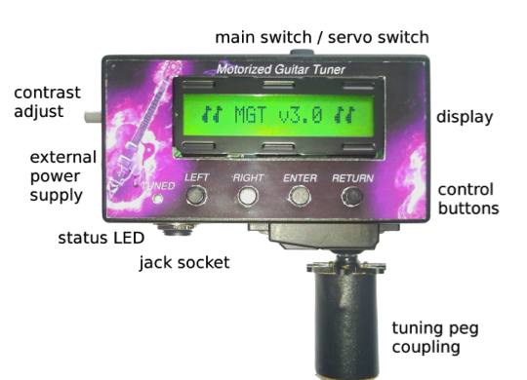

Figure 1 ‘Motorized guitar tuner’

Figure 1

* 1. **Design difficulties with existing products**

From researching into the above project, some difficulties have become apparent. From finding out these difficulties, the objective would be to design the product with these pitfalls in mind, in an attempt to rule them out. In the conclusion of the ‘motorized guitar tuner thesis’, a difficulty regarding tuning accuracy is explained:

*‘Decisive limits of the accuracy of the tuning process are given by the interaction of the different strings with each other and the guitar neck. The device tunes one string without having any information of the tension of the other strings. Changing the tuning of the whole guitar, often more than one tuning process per string is necessary. This effect can get much worse, when the guitar is equipped with a tremolo*.’ (Viehauser, M; Weißensteiner. R. 2012)

It’s important to note these kinds of problems in order to eliminate them in this project. From looking at the complexity of this issue however, a solution is not obvious. From what is discussed; the tuning problem comes from the fact that the tension from individual strings is influencing the overall tension of the guitar neck, which by extension, is putting the other strings out of tune. When a tremolo bridge is used, it means the strings are ‘floating’ (held in a bridge which can move), which means there is more chance for this to occur. With this in mind, the only way to rule out the problem will be to tune all guitar strings simultaneously, which would be a different project entirely.

**2.4 Simultaneous guitar tuners**

In addition to searching through books, journals, university projects and technical papers, the Internet served as an invaluable resource for my research. As a result of a number of searches, an alternative technology was found in the form of a simultaneous guitar tuner (shown in Figure 2)

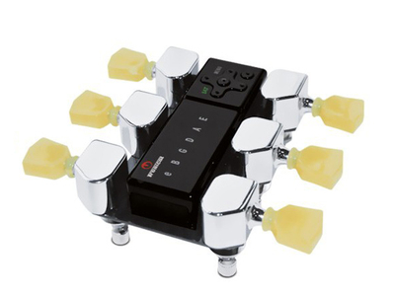

Figure 2 ‘Tronical Tune, Type I’ ([www.tronical.com](http://www.tronical.com), 2013)

Figure 2

The image shown in Figure 2 is a guitar tuner that tunes all 6 strings simultaneously. From my previous research into the difficulties found with tuning one string at a time, this appears to be the perfect solution to such a problem. If, for this project, a simultaneous tuner is chosen for the design, it will negate the problems with other strings going out of tune.

Although this seems like a good idea, with this technology comes new problems. First and foremost, the tuner must always be attached to the tuning knobs (machine heads) of the guitar. This means that the tuner is built-in to the guitar itself. Although this guarantees a robust and accurate tuner, it’s forgetting the original point of the tuner being easy to use, and being versatile. For this project, a tuner that can be easily used on any guitar at a moments notice is definitely preferable. Given the time and budget constraints, to undertake a simultaneous guitar tuner (with multiple signal inputs and multiple position control outputs) would not be feasible. It is however important to note: if such a simultaneous tuner existed for a floating tremolo bridge, it would absolutely be must-have for any high-end guitar users.

**2.5 Feedback loop & Motor specification**

Further to looking through existing products, the motion-control side of the project needed some research. In particular the ‘Motion control handbook’ (S O’Neil, 1998) proved very useful. This document covers both electrical and mechanical aspects of the control system. The section called ‘Building blocks of Programmable Motion Control Systems’ served as an overview of what needs to be done. O’Neil states ‘every programmable motion control system must have the foundation blocks: controller, amplifier, actuator, and feedback’. This is exactly what is fundamental to this project.

Further to this, his technical paper highlighted the necessity to specify the motor type correctly. There are many criteria that the motor must meet in order for the tuner to work correctly. It’s of utmost importance to make sure the motor can overcome the torque required to turn any machine head of any guitar. This means the torque will need to be measured on a variety of different guitars with different string thicknesses, as the string thickness will greatly influence tension. For this reason as part of the methodology, an experiment will have to take place in order to correctly specify the motor.

**2.6 Literature research summary**

As far as literature research goes, some of the documents reviewed were more beneficial than others. This is mostly because during the project planning stage, the concept wasn’t so accurately realized, and therefore the research criteria was more general. For example – going back to the beginning of the literature search – documentation covering brushless motors (Leonard ,2012) and the differences between DC motors and stepper motors was reviewed. From this early research, up until the later research of the ‘motorized guitar tuner’ (Viehauser, M; Weißensteiner. R. 2012), the objectives have been put into perspective and the details of what is required to produce such a device have been fully realised. This information will be taken into account and ultimately will dictate a lot of the content of the Product Design Specification of this project.

**3 METHODOLOGY**

**3.1 INTRODUCTION**

In order to start such an ambitious electro-mechanical project, It was important to outline the individual steps required to begin the experiments and the simulation and eventually manufacture the first prototype. It was also important to follow the timing plan as best as possible given the availability of the laboratory and the equipment. To start off, a flow diagram was made outlining objectives and indicating what needs to happen, in what order, based on the theoretical framework:

Step 1: Interpret guitar signal digitally

Step 2: Specify / order components for use in experimentation

Step 3: Program how to control motor / get Arduino board and motor working together

Step 4: Manufacture prototype

Step 5: Functionality tests / data gathering

Step 6: Software debug /Manufacture final design

Figure 3

**3.2 software selection**

This project is electro-mechanical, and so in order to create the closed loop electrical system, the choice of software needs to happen at this early stage. The most obvious system to use would be Matlab Simulink. This is the software used at Brookes University to simulate various electronic applications. There are three valid reasons why this software was not the preferred choice:

* The software needs to be written to the ATMAL AVR chip on the Arduino board. It would avoid any compatibility problems to use the software provided with the Arduino board and program it in its native programming language. This is referred to as it’s IDE, or integrated development environment, and it uses a code that is almost identical to C++.
* In order to use Simulink, all the simulation will have to happen on campus. Considering the workload, it would be more time-efficient to be able to work from multiple locations, and considering the software came with the Arduino package, using the IDE would be the best choice.
* Speaking from a programming language perspective, the IDE of the Arduino board is a ‘lower level’, meaning it’s closer to machine code than Simulink. It would be sensible to assume that the end goal could be more accurately achieved by investing the extra effort into programming in this language.

For the sake of the project, it might be an interesting point to try to program in both languages, however, due to the time constraint, it’s important to focus on the primary method at this time, this being the Arduino IDE.

**3.3 communicating with the arduino board**

To verify communications between the laptop and the Arduino board, a counter was programmed in the IDE of the Arduino. The output was read with ‘hyper terminal’ (windows-based serial terminal) to check the communications through RS232. This was used for debugging purposes. The output from the Arduino board is 5v and therefore not compatible with RS232. In order to convert the output of the Arduino to be compatible, and RS232 line driver chip (MAX 232CPE) was used to make the

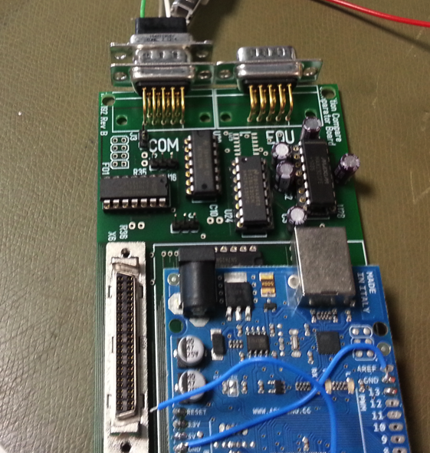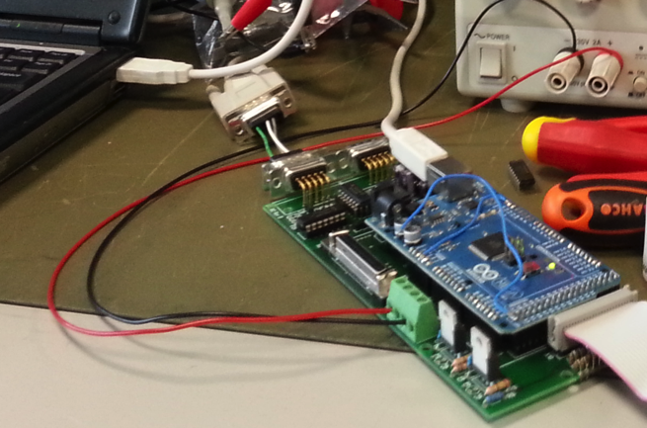

Fig.4

Figure 4 Arduino Board connected to line driver and RS232 comms circuit board

**3.4 Reading the Signal (Input / output check)**

Pin 8 was set as an input for the Arduino board – this would be receiving the signal from the signal generator. Pin 9 was set as an output from the Arduino board – this pin was connected to the oscilloscope, so the signal can be measured from this with respect to ground. As the oscilloscope is now measuring the output, the RS232 circuit board was not needed.

The signal generator is sending a sine wave at a pre-determined frequency to the Arduino board (Pin 8). From pin 9 – which was set as an output – it could be seen that the same signal was correctly displayed on the oscilloscope, however the signal had now become as square wave as it is a digital representation of the analogue sine wave from the signal generator.

Figure 5 verifies that the analogue signal can be interpreted by the digital input of the Arduino board as a square wave for use in the software.

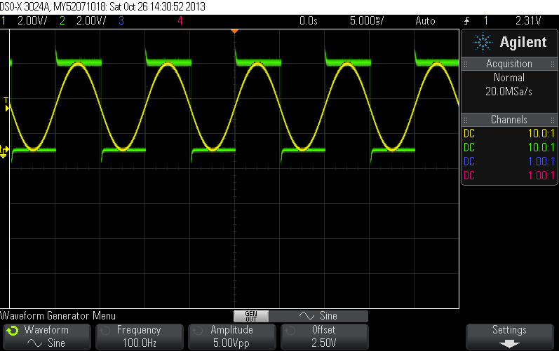

Fig 5

Figure 5 Digital interpretation of analogue guitar signal.

As can be seen, it’s now verified that the signals are the same frequency and that the input/output setup of the Arduino board is configured correctly.

Fig 6 verifies that the Arduino board is interpreting 2.5v as being logic level 1.

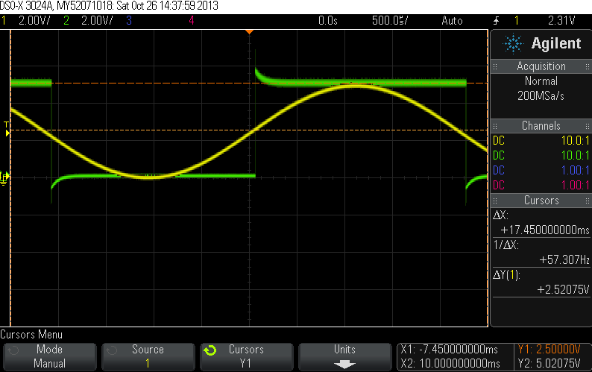

Fig.6

Figure 6 : 2.5v = logic 1.

From these readings, the frequency can be determined. To determine frequency, the time period is measured from peak to peak. The frequency is the reciprocal of the period. In this case, the frequency of the signal is 222 hz.

[9 squares x 500 **μ** seconds = 4.5ms. 1 / 4.5ms = 0.0045 = 1/0.0045 = 222 hz]

**3.5 coding the arduino board**

In order to ascertain that such a signal can be interpreted, Fig 7 shows the code that was created in order to mirror the input to the output. The text with the prefix of ‘//’ are notes made to help with understanding the code.

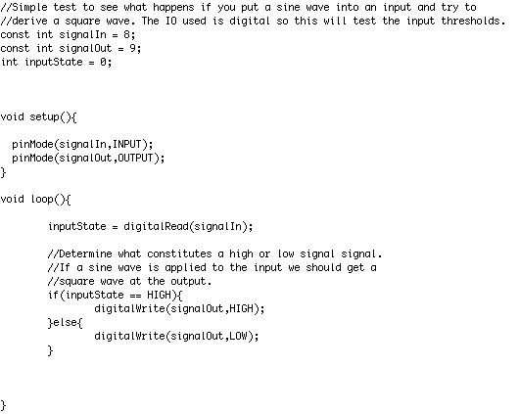

Fig. 7

The above code assigns pin 8 to be and input and pin 9 to be an output, this is done in the ‘setup()’ method. The ‘loop()’ method is executed continuously. In the ‘loop()’ method the state of the input is continuously checked, and depending on its state, it writes to the output. i.e. if the input is on, the output is on. This way we are effectively mirroring the input to the output. As this input is a digital input which we are applying a sine wave to, we are actually determining the switching thresholds of the digital input. The above code should produce a square wave from a sine wave input of the correct amplitude (0V – 5V).

After having successfully read the analogue signal and interpreted it digitally, the next task is to ensure the frequency can be accurately determined. In order to achieve this, further coding is required to not only measure the time period, and thus determine the frequency, but also ensure that the reading is accurate to within 1hz. This was achieved through writing additional code that is included in Fig 8.

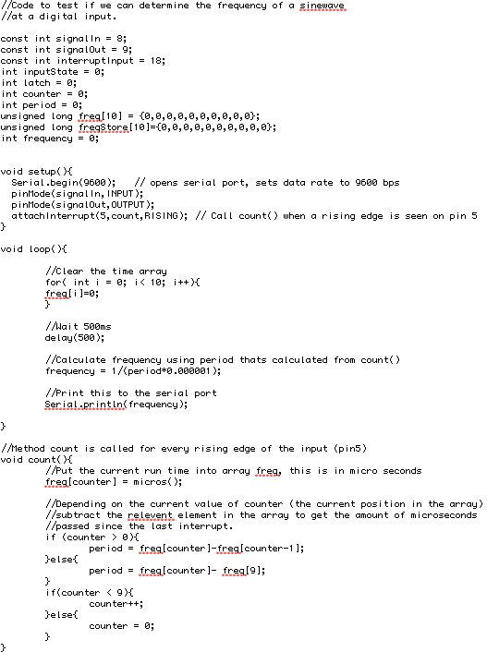

Fig. 8

The code in Fig. 8, was written to ensure the frequency of the input can be read within a reasonable degree of accuracy. As we are reading a frequency which a function of time we must do our best to ensure that the time taken to execute the code doesn’t effect our reading. In order to do this I have chosen to use an interrupt.

In the ‘setup()’ method we have allocated pin 5 to be an interrupt and declared that when pin 5 goes high we will execute the method ‘count()’. When an interrupt is called, it interrupts the standard flow of the program and executes the attached method as a high priority task. Interrupts are ideal for time critical tasks such as this. So, with this in mind, the method ‘count()’ is executed at the very peak of the sine wave input. This method calls a method in the Arduino board called ‘micros()’ that returns an integer that represents the number of microseconds the processor has been powered on, this is basically a high resolution representation of the current relative time. It puts this time into an array. It then increments a counter so that the next time this method is called the position the value is placed into an array is incremented. The method then subtracts the previous value in the array from the current value in the array. This essentially produces the time between the current peak of the sine wave and the previous peak of the sine wave, this is known as the period. There is also a section of code here that deals with wrapping round the position of the array, for example if we are at position 0 of the array we need to subtract position 9 from position 0.

The main part of the code executed in ‘loop()’ simply clears the array, waits 500ms to allow the array to be filled by ‘count()’ and prints the frequency out over the serial port. The frequency is then given by 1/period.

With the above code running on the Arduino board we can send a sine wave into the input at a known frequency from the signal generator. Then by reading the statements printed to the serial port we can confirm that the frequency of the input is correctly interpreted by the software.

**3.6 Reading the frequency from the guitar**

After successfully reading and interpreting the signal from the signal generator, the next task is to be able to read the signal direct from the guitar. This introduces new problems, as the signal from the guitar is not going to be perfect and may contain noise. Also the output voltage is unknown, so it will require some experimentation to determine the threshold to set for the Arduino to consider the signal ‘on’ or ‘off’ and therefore be able to determine the period and therefore the frequency.

In order to set up this experiment, a prototype board was used with an input threshold circuit (a comparator circuit with a potentiometer controlling threshold level) connected between the signal generator and the Arduino board input pin. See Appendix I & J for circuit diagrams.

As can be seen in Figure 9, The board contains both the micro and mega Arduino boards. The bigger of the two boards is being used during the prototyping phase because it’s easier to use and is more reliable when communicating through RS232. Also pictured in Figure 9 is the stepper motor. Getting the motor to operate will be one of the next steps after successfully reading the guitar frequency.

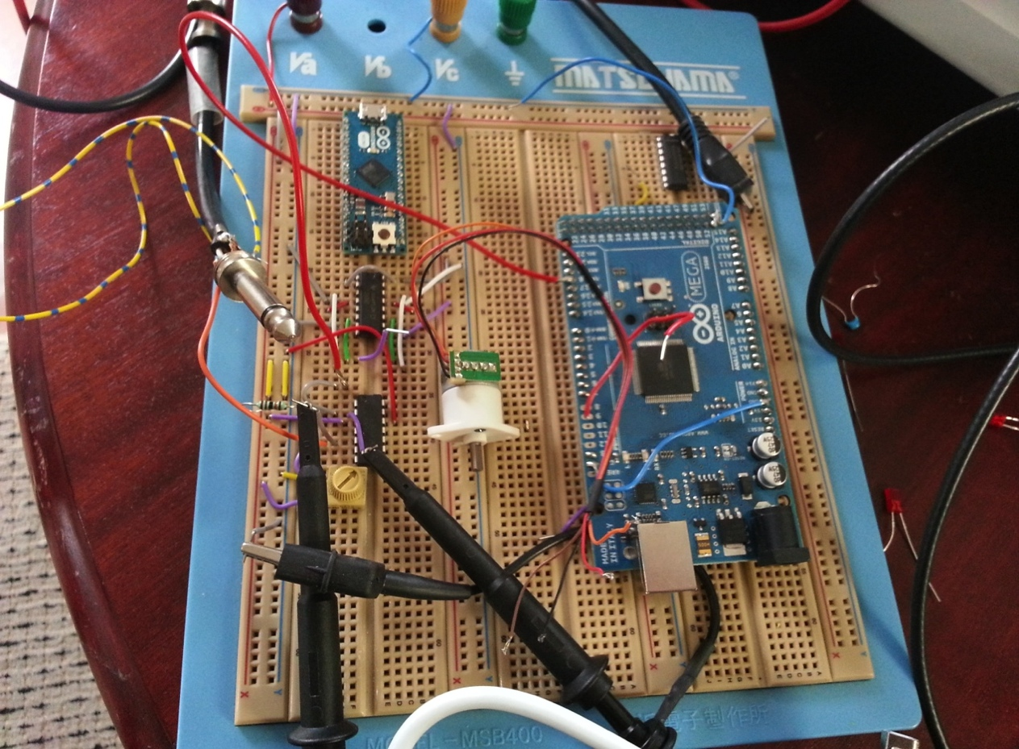

FIG 9

Figure 9 Prototype board experiment.

Appendices D-H show specifications of the Arduino boards used in the experiment; Appendix I & J show diagrams of the circuits used. Only the micro Arduino board is to be used in the final device along with the comparator circuit and the H-bridge circuit.

**Reading the frequency of the Low ‘E’ string – 82hz:**

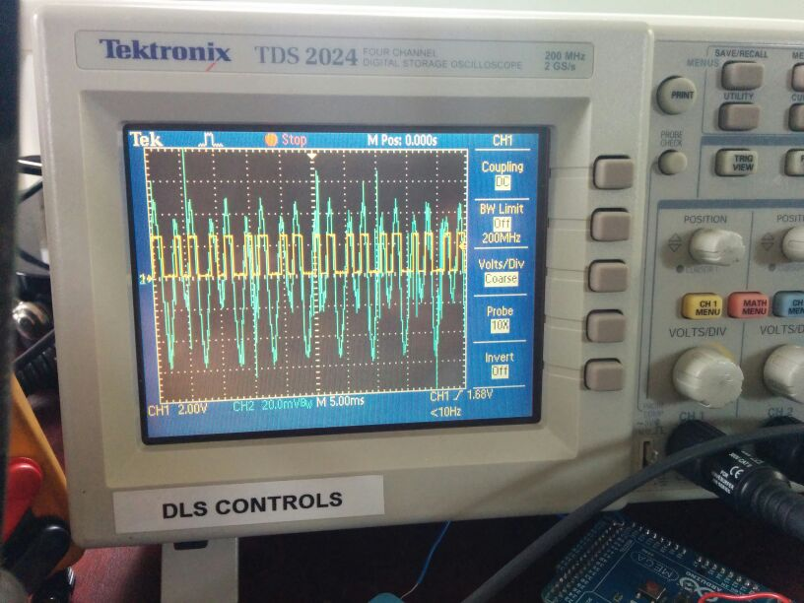

FIG 10

Figure 10 - Trace from ‘E’ string (82hz)

Figure 10 shows the trace from the output of the electric guitar. The yellow trace is the digital signal interpreted by the Arduino board.

As can be seen in this first experiment, there is a lot of noise coming in the signal from the guitar, so the yellow trace is triggering twice per cycle. In order to fix this problem, the threshold needed to be tweaked to ensure that the Arduino is only triggering once per cycle. By tuning the potentiometer, we are setting the input voltage to be slightly higher, so the comparator now will only trigger when it’s ~16mV. From this, a clear digital version of the sine wave was obtained. Figure 11 shows the trace from the high ‘e’ string that was obtained after having set the potentiometer perfectly.

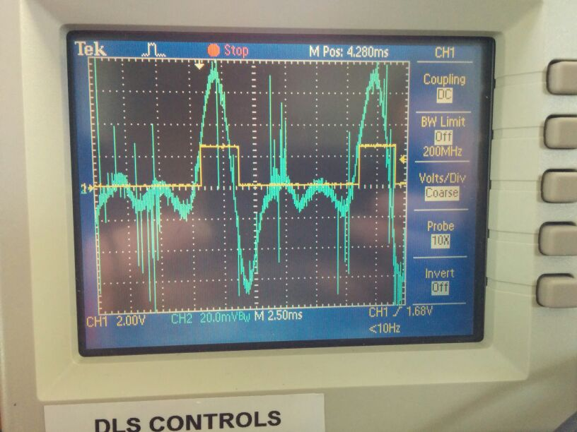

FIG 11

Figure 11 - Trace from ‘E’ string (330hz)

**Reading the frequency of the high ‘e’ string – 330hz:**

Figure 11 shows the trace produced by the guitar when the high ‘e’ string is played. As can be seen, the blue trace has a lot of noise in between peaks, but the threshold of the potentiometer in the comparator circuit is tuned correctly and therefore we have a perfect squarewave of 330hz. The yellow trace is the digital signal interpreted by the Arduino board.

So now the lowest and highest strings are able to be measure and interpreted correctly by the Arduino board, we can begin to take a look at using the signal to tune the guitar.

The traces for the other strings can be found in the appendix (appendices K, L, M & N).

**3.7 Signal problems**

From having conducted the experiment on reading the signal from the guitar strings, it has become obvious that there is a problem that needs to be addressed at this stage of the project.

From having read the signal, 3 different problems have become apparent:

1. The amplitude of the sine wave is influence by how hard the string is played
2. The amount of noise is different on each string
3. Different brands of guitars use different pickups. This means different voltage outputs, therefore different amplitudes, again.

In order to cater for such variance in signal amplitudes / noise, the only way to make a tuner which can reliably interpret guitar signals regardless of guitar brand, string thickness and the way the string is played, would be to process all signals through a ‘normalisation’ circuit (a circuit which can compress all signals to a standard amplitude). However, as the Arduino is successfully reading the signal, the project will continue in its current state. If time is available at the end of the project, to ‘clean up’ the signals from the guitar and make it work across all guitar models, it will be addressed. For now however – with the time constraints taken into account – it will be considered as future work.

**3.8 specifying the dc motor**

Now that the input signal is being accurately interpreted, the next step would be to take the digital waveform, calculate the frequency, and then start to work on driving a motor to match the string frequency with a reference. However, first of all, an appropriate motor must be found. The motor must be powered by a small battery (9v or less) and must be small in size and with enough torque to turn the machine heads of the guitar.

After extensive searching for what motors are available, it became obvious that in order to have enough torque to overcome the machine heads, it would be necessary to have a geared motor. Typically these are quite easy to find, however for this application, the gearbox needs to be concentric to the armature. With this additional criteria, Figure 12 shows the most suitable motor for the task.

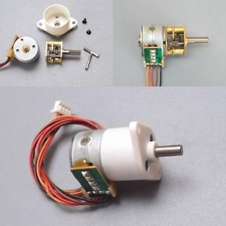

Fig 12

Fig 12: DC5V 2-phase 4-wire Gear stepper motor Full Metal Gear Stepper Motor

As can be seen in Figure 12, the motor is very small and with a concentric gear mechanism. This means that it can fit into cylindrical housing as per the concept design taken from the project log book (Appendix O & P).

Figure 13 shows the actual dimensions of the motor housing

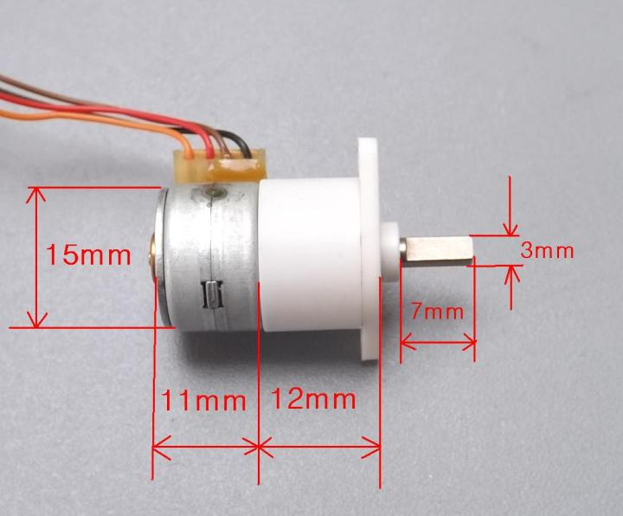

Fig 13

Figure 13: Stepper Motor Dimensions

The specifications of the motor are shown in Figure 14

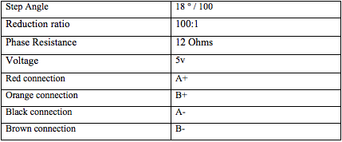

Fig 14

As shown in the specification, the gearbox has a reduction ratio of 100:1. This means that as far as tuning the machine heads is concerned, torque is not an issue. As the strings are tuned, the torque required to rotate the machine head increases. With a gear ratio of 100:1, we can easily overcome the torque needed to tune a string to its correct pitch as from experimentation with an Ibanez guitar; the maximum torque required for tuning the thickest string was about 0.035 N.m.

The torque of the motor is specified as >34.3mN.m and the gear ratio =100:1

Therefore:

Motor torque x Gear ratio = Torque at the output

Output torque: 0.0343 x 100 = 3.43N.m

This means that the motor is over specified for the job, as it is able to deliver almost 100 x the necessary torque at the output. However, in an application such as this where a one-off device is being manufactured, having an over-powered motor isn’t an issue. If this was going to go into mass production, the Inertia of the load would be calculated along with the inertia of the motor. This would be used to calculate the inertia of the system, acceleration torque, load torque, total calculation torque and ultimately, the required motor torque Tm. This would include a factor of safety and would be calculated in accordance with the direct-drive motion profile of the application shown in Figure 15.

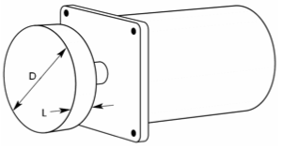

Fig 15 – Direct drive motion profile

LeadShine Technology co., Ltd. (2013) *Motor Torque Calculation.* Available at: www.leadshine.com/Pdf/Calculation.pdf‎ (Accessed: 24th December 2013)

Fig 15

Further to these calculations, in order to more accurately specify a reduction ratio gear box, similar calculations can be made to incorporate the gearbox into the calculation. The previous calculations are neglecting the gearbox, for reasons of simplification. Fig 16 shows a geared, direct-driven load.

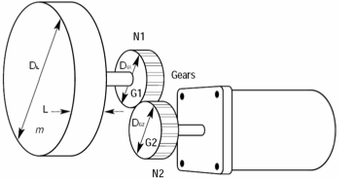

Fig 16 - Geared direct drive motion profile

LeadShine Technology co., Ltd. (2013) *Motor Torque Calculation.* Available at: www.leadshine.com/Pdf/Calculation.pdf‎ (Accessed: 24th December 2013)

Fig 16

As can be seen in Fig 16, In order to calculate the output torque, there are many more factors to be taken into account. In order to specify the perfect motor and gear box for the application, this would be calculated and the cheapest motor with the closest characteristics to the specification would be selected.

In the case of the motor specified for this project, as mentioned before, it’s important to mention that the motor specification is not critical as long as the minimum requirement is met.

There is an further benefit to having a motor with a 100:1 reduction ratio gear box which should be stated. The stepper motor is specified to have a step angle of 18 degrees. The inclusion of the gear box increases the resolution of the system 100 times. This is because with the gear box, the step angle is reduced to 0.18 degrees, which means the system is capable of significantly increased accuracy.

**3.9 Controlling the motor / tuning the guitar**

When programming the next stage of the software, the IDE of the Arduino board was once again used. This time however it was written in notepad++ first, to make it easier to read.

All the necessary comments are contained within figures 17 - 20, however the for further clarification purposes, the software will briefly be explained.

First and foremost, the fundamentals of the motor control are defined: Number of steps per revolution, stepper speed in RPM etc. After this, the upper and lower frequency boundaries for each string are defined in an array. This determines what the highest and lowest frequencies are that are acceptable for each string. i.e. for 100hz (A2 string), the lowest is 96hz and highest is 128hz. Anything above 128hz will be tuned to the string above, any thing below 96hz will be tuned to the string below. After defining the array of upper and lower boundaries, an array is made for the reference frequencies, followed by the ‘if’ statement dictating which strings should be tuned to what frequency. Following that is the code required to drive the stepper until it reaches the deadband of 1hz. Also included in the code is the calculation of the frequency and the part of the code from the beginning which was interpreting the singal. Figures 17 - 20 show the final code for the Arduino board.

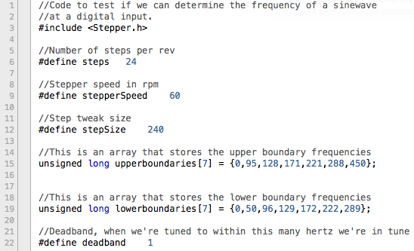

Figure 17

Figure 17 – Final software used in Arduino board

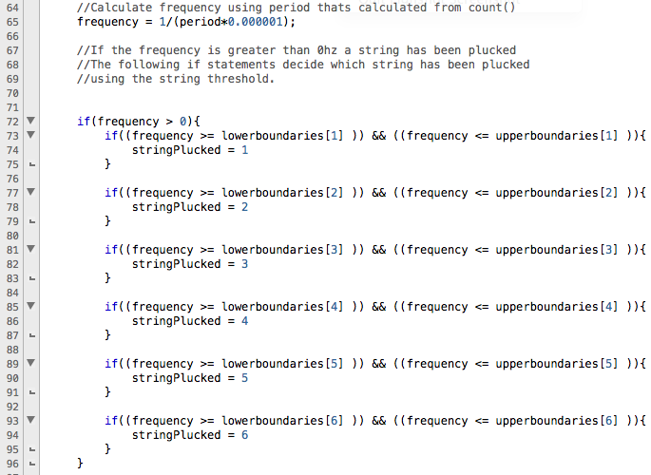

Figure 19

Figure 19 - Final software used in Arduino board

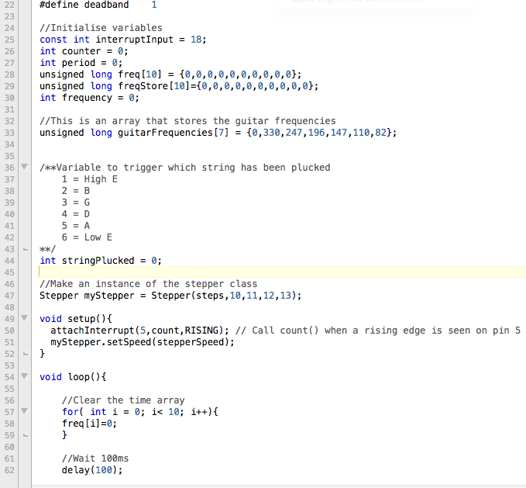

Figure 18

Figure 18 - Final software used in Arduino board

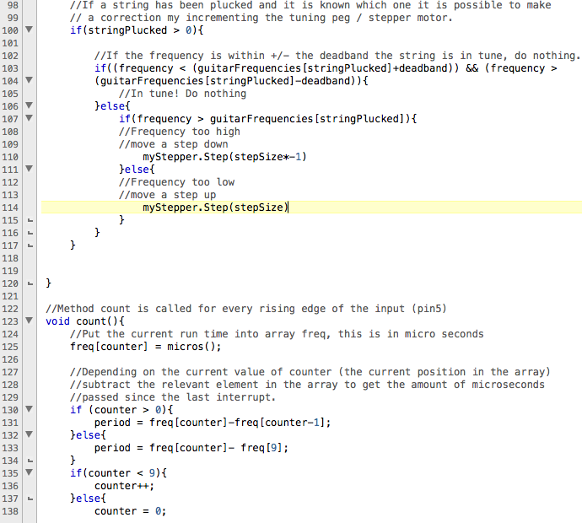

Figure 20

Figure 20 - Final software used in Arduino board

**3.10 Manufacturing the prototype**

Appendix Q & R show the CAD diagrams made in order to produce a rapid prototype. SolidWorks was used to make the 3d models, which were then exported as files that can be used by the SLA machine. Figures 21 & 22 show the prototype model.

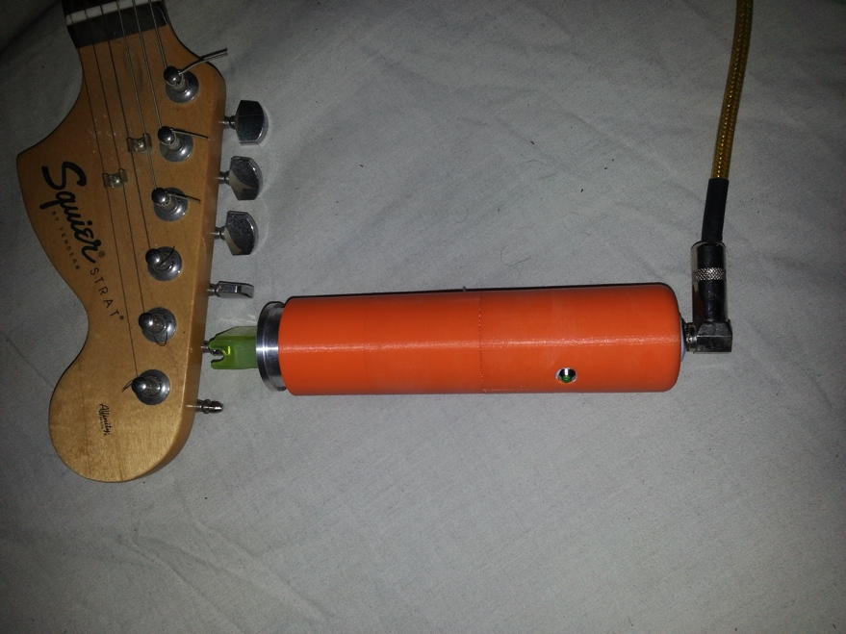

Figure 22

Figure 22 – prototype being tested

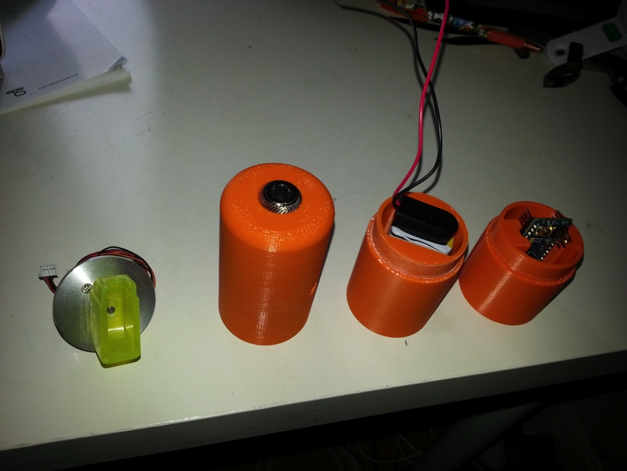

Figure 21

Figure 21 – Rapid prototype, individual components

**3.11 Manufacturing the final Design**

In order to manufacture the housing for the tuner, the original design from the prototype was altered to become one piece. Using a lathe, a piece of 35mm diameter, 3mm thick steel tube was cut to size used for the body. Two end caps were then made for the jack input and the motor side. A thread was cut for the end cap for the jack input side and an internal thread for the tube. The tube was knurled to make it easier to grip during operation, and 2 holes drilled for an LED and an On/Off switch shown in Figure 23. Figure X shows the end cap construction with the Jack input.

Figures 25 and 26 show the assembly of the motor end cap. A hole was drilled for the motor shaft to come through the housing. The yellow plastic piece is part of a ‘string winder’, it’s aperture fits perfectly over the machine head of any guitar. This was also drilled into and bonded to the shaft with adhesive.

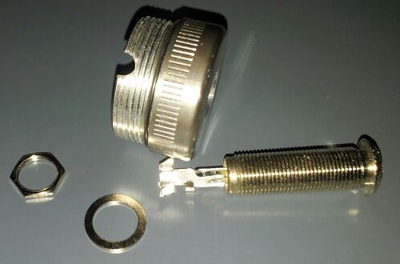

Figure 24

Figure 24 – Jack input components and end cap

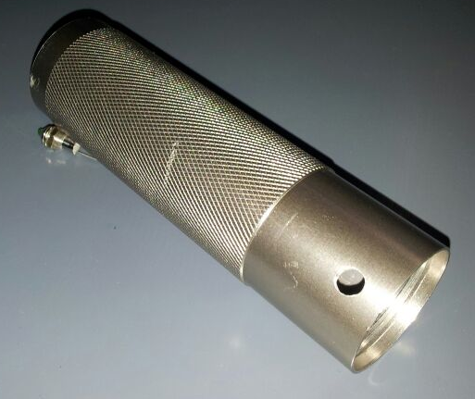

Figure 23

Figure 23 – Guitar tuner housing

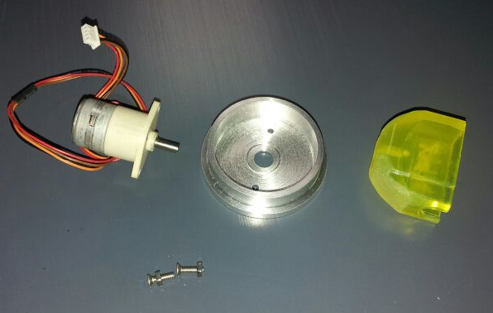

Figure 25 – Stepper Motor, End cap and string winder components

Figure 25

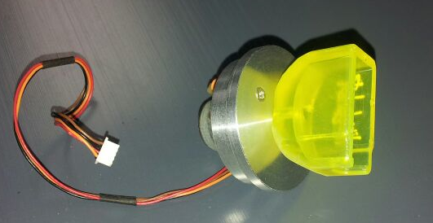

Figure 26 – Motor end cap assembly

Figure 26

After the housing was made, the components (9v battery, motor, LED, switch, and jack input) were slotted into place.

**3.12 Limitations of the methods employed**

As far as the methodology is concerned, the steps taken have been logical and comprehensive. However, some limitations have forced some aspects to be overlooked. The limitations encountered are as follows:

* Lack of diversity with guitar models for experimentation
* Manufacturing methods – no rapid prototype
* Resource constraints
* Cost constraints

These limitations will be covered in further detail in the conclusion.

**4 RESULTS**

Due to the nature of this project, there is little data to be analysed. Either the system corrects its radial error according to the reference, or it doesn’t. The only data to be analysed (apart from the analysis / filtering of the input signal, in the methodology section) is the accuracy of the frequencies obtained from using the final design.

Appendices S, T, U show the results taken from different tuning operations. This experiment involved tuning ALL the 6 strings which were offset from their reference frequency by (+/ – ) 2-20hz. The end frequency was then measured directly from the guitar to establish the accuracy of the tuning operation. Appendices S, T, U show the data, plus a column showing whether or not the tuner has worked for each string.

**5 discussion**

From having tabulated the results of the experiment, it can be seen from first glance that the radial error correction is working to an accuracy of < 1hz from the reference frequency.

As can be seen in Appendices S, T, U there is still an error even after the machine head has been rotated, it’s therefore important to note the reasons for this remaining error. The resolution of the tuner is to the nearest 1hz, as - from experimentation - it was not considered necessary to work in decimals because it was found that the difference of anything less than 1 hz was almost imperceptible to the human ear. This was the reason why the resolution was set as such. Again it seems an ideal time to consider this as a possibility for future work, as it would take only fine-tuning of the software to make this possible. For now however, the accuracy level is perfectly acceptable. It should also be noted that the stings of G3 and E2 already fall perfectly on an integer, so that’s why the error was zero.

Further to this, it should be noted that some rounding of values has taken place. This again was because we are only tuning to the nearest integer. Therefore the reference frequency for the strings E,B & D were rounded up to 300, 247 & 147 respectively, and the low E string was rounded down to 82hz.

With regards to the time taken to rotate the machine heads, each operation was less than one second. This happened every time. The small amount of time taken was influenced by the fact that the error was always less than 20hz each time. But also because the speed of rotation was ideal.

So far, the functionality of the finished device seems to meet exactly what was set out in the aims and objectives section of this report. However looking at the results of the radial correction when the error was larger, it can be seen that there is a significant problem. When the error introduced to the system is greater than 12 hz (14,16,18, 20hz), we can see that the software is assuming that a different string is to be tuned. For example when referring to Appendix U, we can see that the ‘E’ string (82.41hz) has been tuned all the way up to 110hz. Also, the ‘A’ String (110hz) has been tuned up to 147hz. This can be easily explained, but is most definitely a limitation of the system.

The software is looking to tune the frequency of the guitar signal to a reference of what that particular string should be. However, when the error is too large, the software is trying to tune the string to the frequency of an incorrect string. i.e the string above, or below, depending on whether the error introduced was positive or negative. To explain this better, Figure 27 shows the upper and lower boundaries associated with each string.



Figure 27

Upper and lower boundary conditions for determining frequency

A2 tuned incorrectly to D3

A2 corrected

E2 tuned incorrectly to A2

E2 corrected



REF D3 146hz

REF E2 82hz

REF A2 110hz

Figure 29

Chart showing 2 notes with errors of +12 hz, and +20hz



REF D3 146hz

REF A2 110hz

REF E2 82hz

E2 with +12 hz error

E2 with +20 hz error

A2 with +12 hz error

A2 with +20 hz error

Chart showing 2 notes with errors of +12 hz, and +20hz

Figure 28

In order to visualise this incorrect frequency adjustment, Figures 28 & 29 visually show what happens when a string is too far away from the reference frequency and is tuned to the one above. The information in Figures 28 & 29 have been taken from the data in the ‘data analysis’ section and was made just for further clarification.

When considering the problem of tuning to the wrong values, there is again scope for future work to improve on this. The reason why the problem exists is because the device has no user input and you therefore cannot define the string it’s supposed to be tuning. This feature was originally one of the unique things about this project, but as the project has developed, that may not be a positive feature. The idea of a tuner that ‘knows’ which string you’re going to tune, and does it automatically is an excellent idea. However, with the issues experienced, the project could have functioned better if it had user input, in the form of a string selector switch. That being said, with more time and the benefit of seeing these various problems develop, a solution to this problem could be found. Again this is something which will be covered in ‘future work’.

Going back to the data, we can say that this guitar tuner can correct frequency errors of up to 12hz. This might not sound like a lot, but for a tuner that can be picked up and tune your guitar automatically without the user needing to understand guitar tunings, it is plenty. After adressing the limitations of the error correction, it has become obvious that this project would be used to tune a guitar which has simply ‘gone out of tune’. If the user wants to replace strings and tune from scratch, this tuner will not work at all as the signal frequency from the untuned strings would be too low, and therefore the tuner would try and tune all the strings to the lowest option (E2).

To draw a comparison with between the final result and the theoretical model behind this project, it can be seen that the functionality achieved, fulfils exactly what was set out to achieve. The device takes a signal, and rotates the machine heads until the difference between the signal and the reference signal is zero, thus correcting the error, and rotating the machine head to where it’s supposed to be. To go back to the literature research, In particular the ‘Motion control handbook’ (S O’Neil, 1998) O’Neil states: ‘every programmable motion control system must have the foundation blocks: controller, amplifier, actuator, and feedback’. With all these ‘foundation blocks’ in place, our closed-loop motion control system works as required, but is by no means perfect.

For further discussion, in order to really reflect on the success of the project we need to again revisit the literature and the study of existing products. To go back to the ‘Tronical’ guitar tuner (simultaneous tuning device), we need to ask ourselves how this tuner compares.

Obviously with the limitations of resources for manufacture and a limited budget etc, the project (in this design phase) was never going to compete aesthetically. However, providing that the functionality issues of this project are overcome in the ‘future work’, the device itself still serves more of a purpose than what is on the market. The tuner in this project could be considered an ‘after-market’ tuner and can be retrofitted onto any guitar in a matter of seconds. The simultaneous tuner does not allow this, and that is why this project excels as a concept.

**6 Conclusion**

In order to conclude the project, the original objective needs to be revisited and compared with the outcome.

In the early pages of this report, the objective was laid out: ‘to design and build an electro-mechanical system which can automatically tune an electric guitar’. The integral part of this a device was to be a closed loop system to correct the radial position error of a shaft –in this case, a machine head (tuning peg) on a guitar headstock. The outcome, or final result, is a fully functioning automatic guitar tuner which detects which string is being played, and – when attached to the machine head – will rotate the machine head until the string comes into tune to an accuracy of >1hz.

If the user wants to tune a guitar, they simply place the tuner on the correct machine head, play the string, and the motor will correct the radial position error of the machine head, and the string is tuned. The user then moves to the next string and the process is repeated until all strings are tuned. There are no buttons on the device, and the user does not need to understand how to tune a guitar, or which string is corresponds to what note (or frequency). The device is stand-alone, battery powered and – theoretically – can be used to tune any guitar.

Considering the outcome fulfils the objective of this project, it can be considered as a success. Due to time constraints, it’s not possible to make a ‘universal’ tuner that can repeatedly and accurately tune any guitar. However, this project has left considerable scope for future work, and has actually highlighted a niche in the market for a similar device, which will be explained at the end of this section.

To draw a conclusion from the data analysis, the tuner works as required when a string is + / - 12hz from it’s desired pitch. A valid question to ask would be ‘how much is 12hz?’ that however is a difficult question to ask. As the pitch of a note is measured in ‘cent’, an appropriate answer would be to transpose the musical equivalent of the frequency into cent, and find out how much the tuner can correct in both hz and cent. The problem lies in the fact that the cent is a [logarithmic](http://en.wikipedia.org/wiki/Logarithmic_scale) unit of measure of musical [intervals](http://en.wikipedia.org/wiki/Interval_(music)). Therefore it’s not possible to say that the tuner can make a correction of a semitone (100 cent) or a whole tone (200 cent), which musicians would consider ‘half a note /pitch’ or ‘a whole note / pitch’. However as we know the range of the string frequencies is from 82 – 330 hz, the 12hz error, when considering the pitch (measured in cent) equates to between 64 cent and 236 cent. For the lowest string, this means: the string can be just over ¼ of a note incorrect. For the highest string, this means: the string can be ~1 ¼ notes incorrect.

The error conversion into cent is necessary to conclude the project, as the end user will be a musician, so frequency is not necessarily the unit of measure in focus. As explained on the Hyperphysicswebsite*,* (Nave, C. R. 2013), in order to convert frequency into cent, you must first take the two frequency values, between which you want to find the value in cents (c or ¢) - This is called the interval frequency ratio – and substitute the values into the formula:

¢ or c = 1200 × log2 (f2 / f1)

So for an interval frequency ratio between the upper boundary of the lowest string and the reference, or desired, frequency:

¢ or c = 1200 × log2 (95 / 82)

c = 236.444

c = ~1 ¼ notes

Therefore, for that particular string, an error of 1 ¼ notes can be corrected.

So this level of error correction for a musician would be ample, however for a string with a higher frequency, the error correction is significantly less. This is the downfall of having an ‘intelligent tuner’ with no user input.

Having calculated the accuracy and the ability to correct errors, it’s important to visit one of the objectives from the beginning of the project, specifically the ‘measurable’ SMART objective.

Earlier in the project, the following statement was made:

*“The performance of the product can be observed and measured. The tuner must be able to rotate the shaft until the reference pitch is achieved. This will be later compared with human perception and explained as to what accuracy is considered acceptable by the end user”.*

This objective is important to define whether or not the project was a success. Firstly, it can be said that the tuner has an accuracy of >1hz, so it succeeds with the criteria of ‘rotating the shaft until the reference frequency is achieved’. However a statement was made regarding the perception of the human ear. As stated previously through experimentation, it was not possible to hear differences of less than 1 hz, but this different for every person. Nave, C. R. (2013) explains ‘The just noticeable difference (JND) in pitch is conveniently expressed in cents, and the standard figure for the human ear is 5 cents.’

This shows that, not only does the tuner meet the accuracy criteria, but it can also tune the guitar when the amount of error is not perceivable by the human ear. The tuner can work within the ‘just noticeable difference’ cent range, and tune your guitar even if it sounds correct to the human ear.

To correctly conclude, it’s also important to revisit the other SMART objectives. We already know that the **specific** and **measurable** objectives are met, but further to this, the **achievable** and **time**-**bound** are met, as the project is complete and functional before 23-04-14 (Appendix V is a revised timing plan that has been updated to show the exact time taken for each task). The **Relevant** SMART objective however, is a slightly more debateable subject. This is because – although the tuner works and is needed in the industry – as it stands, its functionality is not perfect. This leads perfectly to the plans for future work.

**6.1 future work**

Throughout this project is has become apparent that there are many things that can be done to improve the functionality. Firstly, the scope for future work will be outlined, followed by a suggestion for a separate project. This project is one that would perfectly meet the **Relevant** SMART objective, as it would be more functional, more practical and more reliable in the industry. It would however take a lot more time and research to manufacture, but the realisation of such a project, can almost be considered as the outcome of **this** project.

Future developments for this project:

* Develop a ‘normalisation’ circuit (a circuit which can compress all signals to a standard amplitude) before the signal is interpreted by the Arduino board. This would mean the guitar can be tuned regardless of the output voltage of the guitar pickup, and regardless of how hard the string is played. Thus making the tuner ‘universal’, for use on any guitar.
* Increase resolution to 0.1hz. This would enable the tuner to work to a finer accuracy. It’s not necessary for this project, but if it were to be released into the market, it would be tweaked as such to eliminate errors of less than 1hz.
* Include a string selector switch. This is something that was avoided, because the concept was to make a tuner which eliminated user input. It would work by having 6 separate input threshold circuits (or one normalisation circuit) which can interpret the different strings frequencies reliably and correct -theoretically – infinitely large or small errors. This would improve the functionality of the tuner as the user could effectively tune from scratch. i.e. tune a guitar with new strings. It would however require the user to have a fundamental knowledge of which string corresponds to which note. That’s why it wasn’t implemented from the beginning.

**6.2 future projects**

As said previously, through developing this project, a need for a new project has been realised. With all the pitfalls discovered with this technology, there is one device that would not only have improved functionality, but would fill a niche in the industry that no currently available product has managed. This would be to manufacture a simultaneous guitar tuner for a ‘Floyd rose’ bridge. This topic was briefly touched upon at the beginning of the project, but will be expanded upon in further detail.

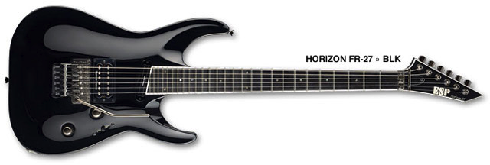

Figure 30

Figure 30 - ESP guitar, available at: ‘www.premierguitar.com’ (Accessed: 19th March 2014)

Figure 30 shows a guitar model with both standard machine heads – highlighted on the head of the guitar, and Floyd Rose ‘fine tuners’ – highlighted on the body of the guitar.

As mentioned earlier, most professional musicians will choose a guitar with a Floyd Rose bridge. This is because it allows you to bend the pitch of a note with the ‘whammy’ bar, and also it enables the user to have more accurate control of guitar tunings.

The problem faced with such a guitar setup, is that the machine heads on the headstock must first be tuned, and locked into place. The guitarist then uses the fine tuners on the body of the guitar to make adjustments. Even for professional musicians, it’s considered to be an arduous task to tune a guitar with a Floyd rose bridge. This is because it must be approached with additional care and finesse, as each time a string is tuned, the flexing of the fret board (or neck) can cause other strings to become out of tune. The task of tuning the guitar is normally left to a guitar technician who will methodically tune the strings in a particular order, as the thickness of the strings (with respect to each other) and the gauge of strings chosen by the player, affect the flexing of the fret board differently.

Because this task requires the help of a professional, if a product was developed to eliminate this problem, it would make the job of the technician considerably easier.

Figure 31 shows a concept diagram taken from the project logbook. It shows the basic idea of what would need to be manufactured. The technology behind it however, would be considerably more complicated than first thought.

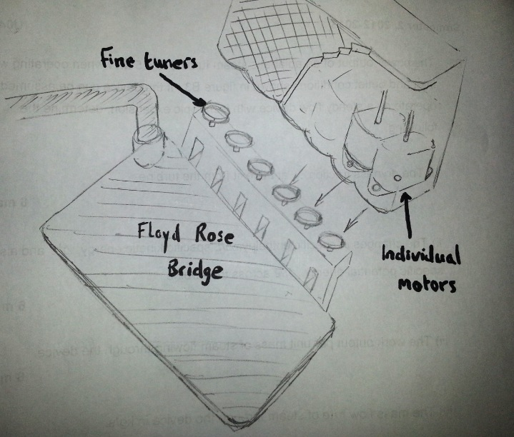

Figure 31

Figure 31 – Concept sketch of simultaneous Floyd Rose tuner

The concept would be to have a device that can fit over all 6 fine tuners at the same time and tune them with individual motors. This would mean that there would be no need to change between strings. The most important thing tuning a Floyd rose bridge is that the user must repeatedly tune the strings in one tuning session, as tuning other strings pushes the others out of tune. Therefore, the idea behind this tuner would be for the tuning process to tune all 6 strings simultaneously and continuously until the strings are all in tune. This means playing all 6 strings with one strum on the guitar.

The benefit of this is that the tuner could be programmed in such a way to know what actions cause which strings to de-tune, so it could make constant adjustments until the references are all met.

In order to achieve this, there would need to be a lot of research and studies on what influences the tunings, and distinguishing which string is which would pose a new problem. It would involve a lot of signal analysis or instead, a new way to detect the frequencies – through vibration or a direct connection to the 6 magnets on the pickups.

This project would certainly be a first in the industry, although the level of technology would probably be significantly more complicated.

To return again to the project in hand however, the end result is almost exactly what was set out to achieve, and the future work enables more exciting developments to follow. Figures 32 and 33 are labelled diagrams of the finished project.

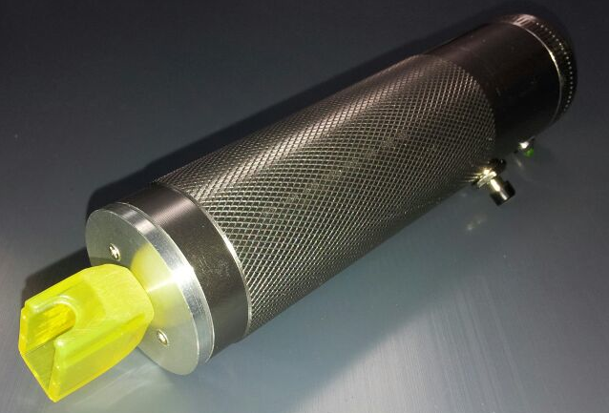

Figure 33

Figure 33 – Finished device

‘String winder’ coupled to stepper motor

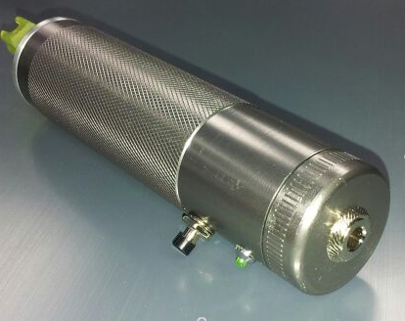

Figure 32

Figure 32 – Finished device

On / Off switch

Tuning ‘OK’ LED

Jack lead input from guitar

Knurled grip

**7 REFERENCES**

* Nave, C. R. (2013). *Hyperphysics*. Available at: <http://hyperphysics.phy-astr.gsu.edu/hbase/hframe.html> (Accessed: 24th December 2013)
* O'neil, S. (1998). *Motion control handbook*. pp 1-38.
* Tronical GmbH (2013). *Tronical tune, type 1.* Available at: http://www.tronical.com (Accessed: 24th December 2013)
* Viehauser, R, Weissensteiner, M. (2012). *Motorized guitar tuner*. Dipl. Ing Telematics. Graz, University of Technology.
* **8 BIBLIOGRAPHY**
* Ahmed, M. S, Zungeru A. M (2012). *Development of a duel heater control system*. Development of a duel heater control system (2), pp. 127-136.
* Djaferis, T. E. (1998). *Automatic control: the power of feedback using MATLAB*. Boston: PWS Publishing.
* Dorf, R. C. (1998). *Modern control systems*. Harlow: Addison Wesley.
* Harbor, R., Phillips, C. L. (2000). *Feedback control systems*. 4th ed. London: Prentice-Hall.
* LeadShine Tecnology co., Ltd. (2013) *Motor Torque Calculation.* Available at: www.leadshine.com/Pdf/Calculation.pdf‎ (Accessed: 24th December 2013)
* Maharem, A. N, Reseka, S. F., and Elsodany, N. M. (2010). Adaptive PID control of a stepper motor driving a flexible rotor. *Alexandria Engineering Journal* (50). pp 127-136.
* Newton, J. L. (2012). *Controlling a brushless motor*. BSc Engineering thesis. Oxford Brookes University.
* Nichols, N. B., Zeigler, J. G. (1942). *Optimum Settings for Automatic Controllers*. Transactions of the American Society of Mechanical Engineers (64). pp 759-768.
* Rizwan, M. (2009). *Controlling air driven motor with Arduino board*. BSEng thesis. Oxford Brookes University.**9 APPENDICES**



Appendix A

Project timing plan (initial)

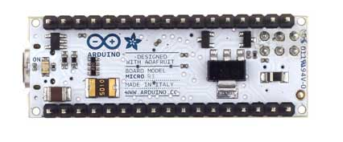

Appendix C

Nano Arduino board – under side of circuit board

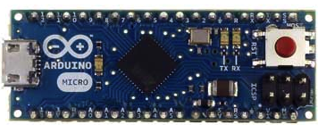

Appendix B

Nano Arduino board used in final design

Appendix D

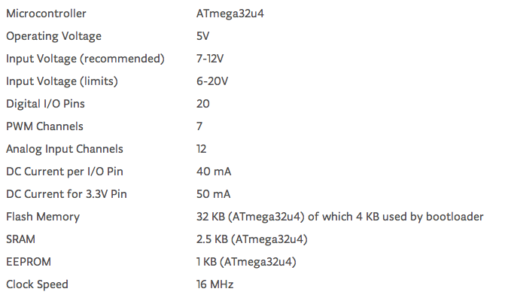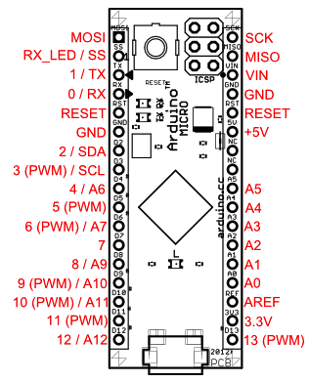

Nano Arduino board pin-out diagram and specification



Appendix E

Micro Arduino board schematic

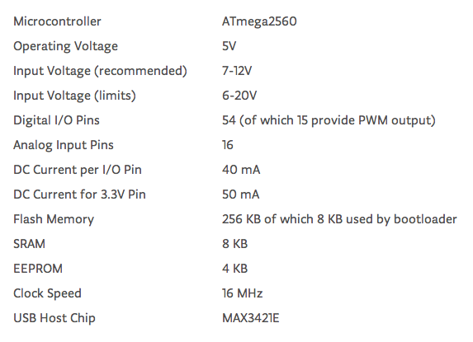

Appendix H

Mega Arduino board specification

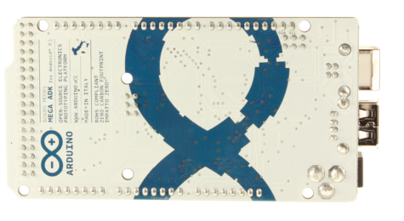

Appendix G

Under side of Mega Arduino board

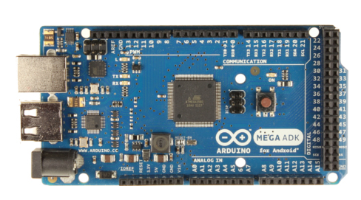

Appendix F

Mega Arduino board, used only for prototype

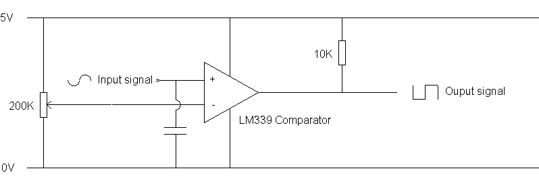

Appendix I

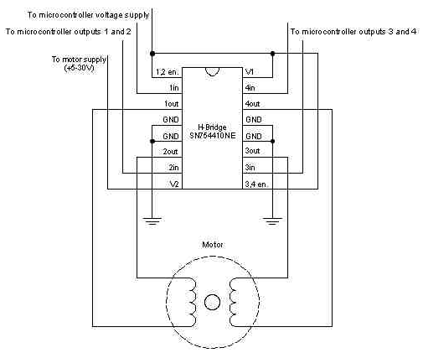

Appendix J

Fig 10. H-Bridge circuit used to drive the stepper motor. Available at: <http://arduino.cc/en/uploads/Tutorial/bipolar_schem.jpeg> (Accessed: 24th December 2013)

Comparator circuit or ‘threshold’ circuit, used to set the input amplitude. The output signal goes directly to pin 8 of the Arduino board.

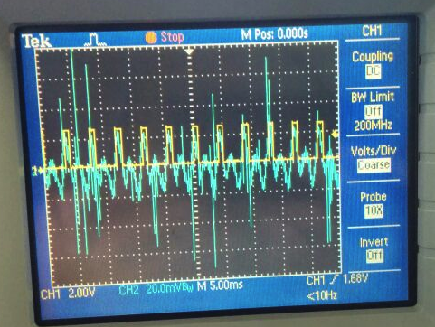

Appendix L

‘D’ string trace. Green = guitar, Yellow = Arduino square wave.

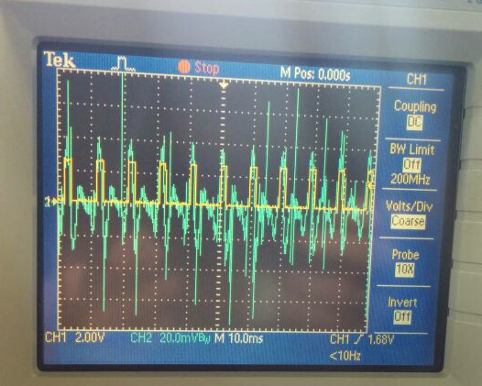

Appendix K

‘A’ string trace. Green = guitar, Yellow = Arduino square wave.

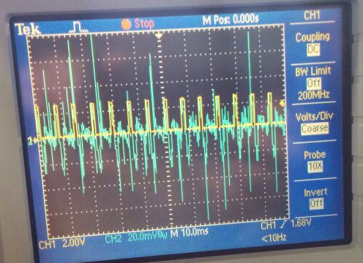

Appendix N

‘G’ string trace. Green = guitar, Yellow = Arduino square wave.

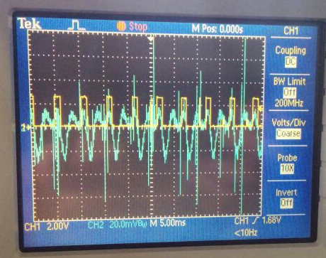

Appendix M

‘B’ string trace. Shows incorrect triggers.

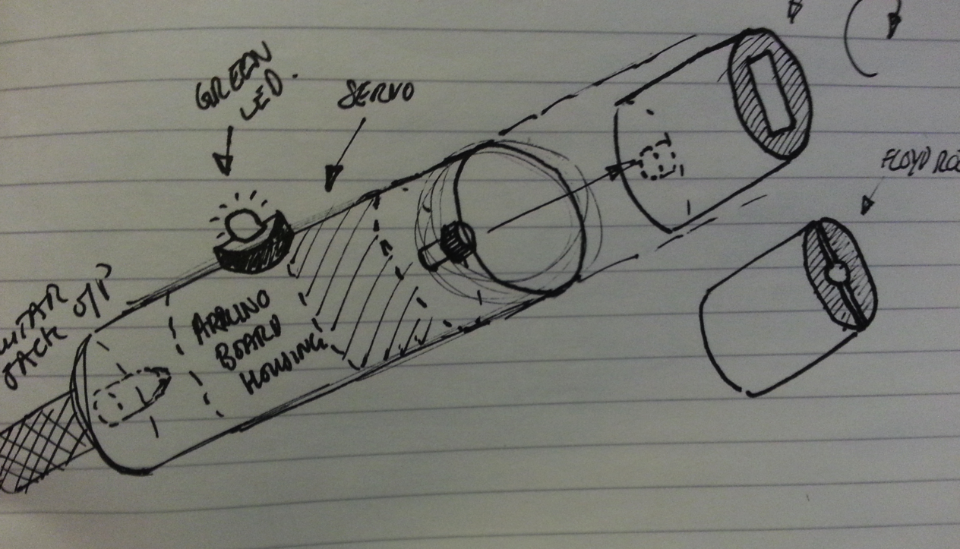

Concept sketch of position controller housing

Appendix O

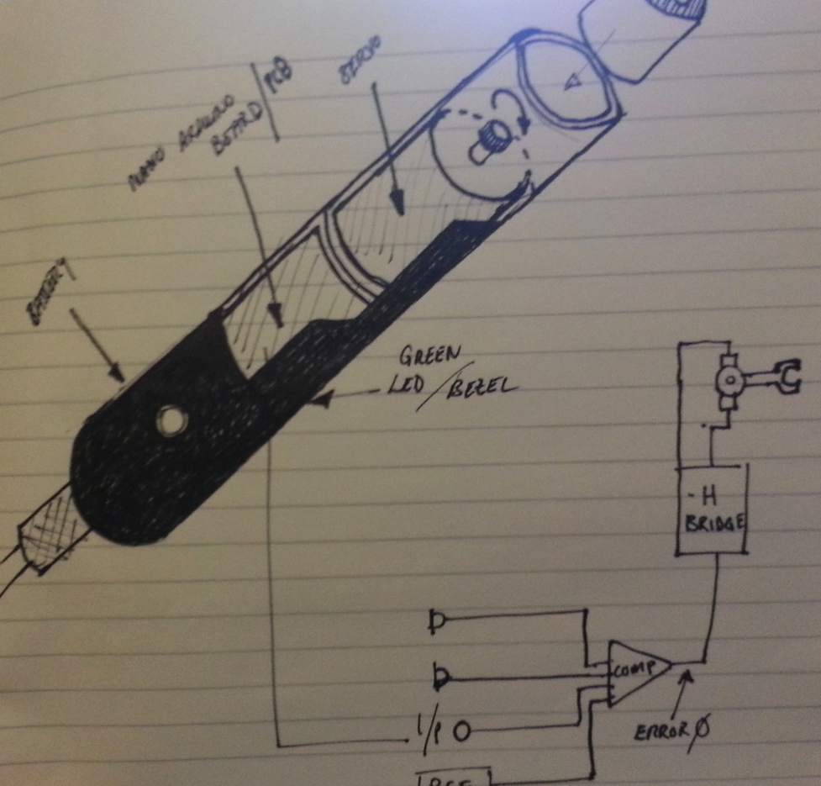

Detailed concept sketch of position controller housing

Appendix P

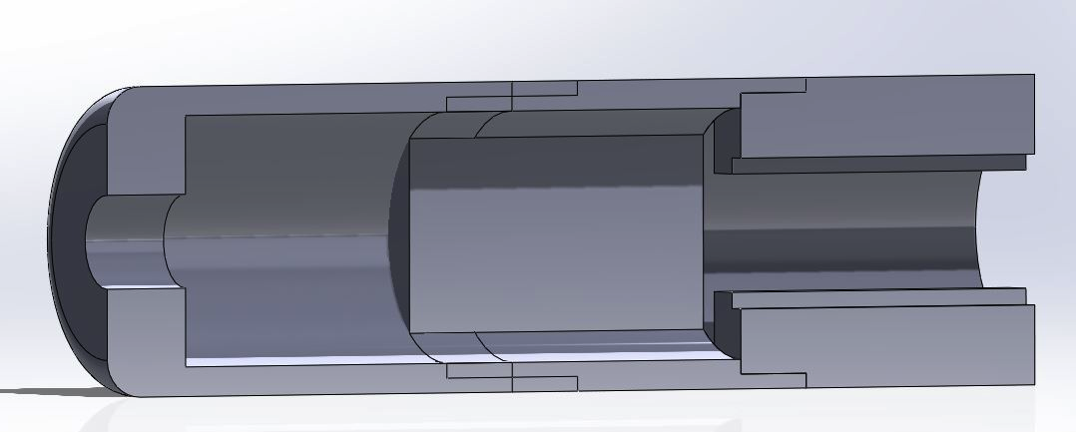

Cross-section of device

Appendix R

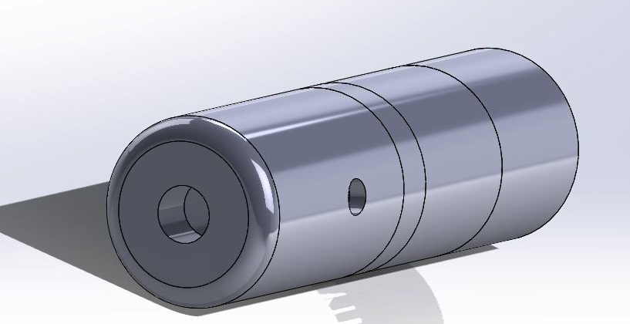

CAD drawing of initial concept

Appendix Q



Appendix S

Tabulated results of tuning experiment from +/- 2hz error – +/- 6 hz.



Appendix T

Tabulated results of tuning experiment from +/- 8hz error – +/- 16 hz.

Appendix U



Tabulated results of tuning experiment from +/- 18hz error – +/- 20 hz.

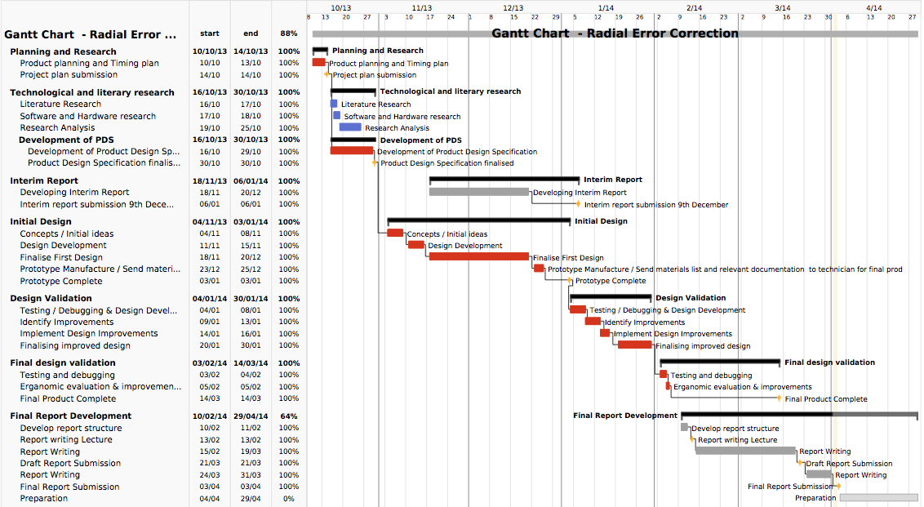

Appendix V

Updated timing plan – created after project completed



**END OF DOCUMENT**